Report for edificio residencial

1. Time Series Characterization
Mean consumption: 333.09547738693465
Median consumption: 328.5
Std deviation: 196.7414545262808
Minimum consumption: 12
Maximum consumption: 1251
95th percentile: 634.0499999999998
Total records: 398
Above Normal deviations: 16
Below Normal deviations: 2

2. Consumption Line Plot
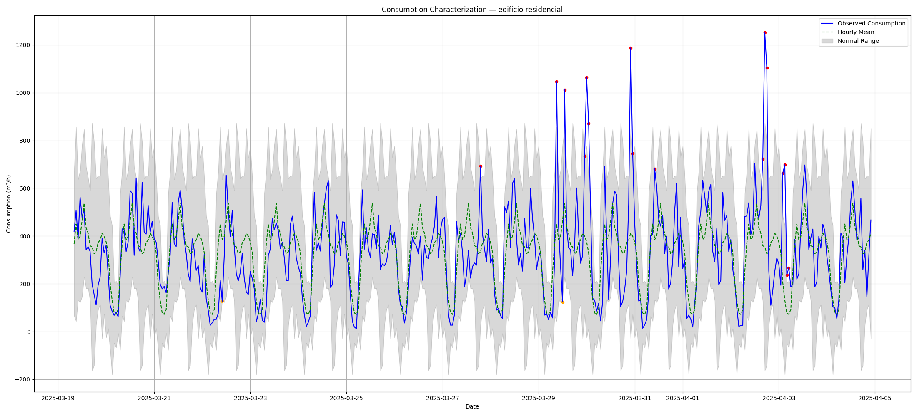

3. Deviation Heatmap
